
NAME: BISMA FATIMA
CLASS: CS A
ROLL NO: F24605036
COURSE: INFORMATION SECURITY
COURSE CODE: CS-291
LECTURER: MISS ATTIA ASHRAF

MID SEM EXAM

Task 01:
o Create a new directory:
COMMAND:
mkdir new_directory
OUTPUT:
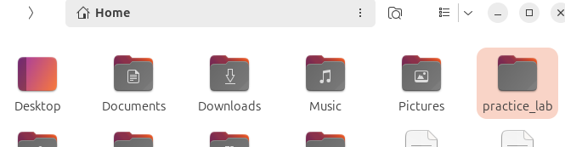

o Create a new file:
COMMAND:
Touch newfile.txt
OUTPUT:

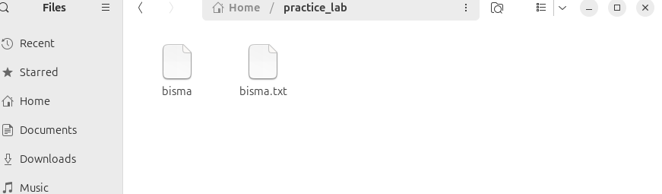

- status
Sudo ufw status
OUTPUT:
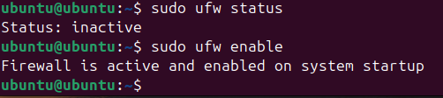

- install
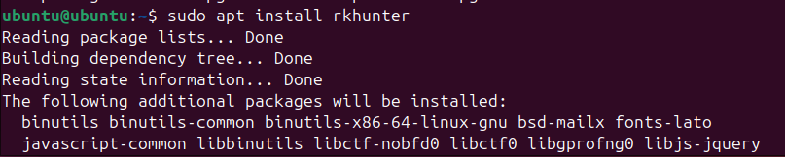

TASK 01
PART 01 AES

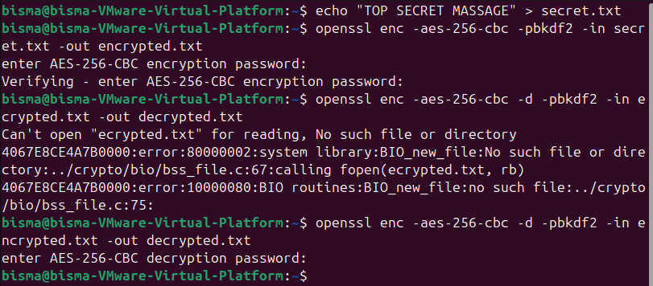
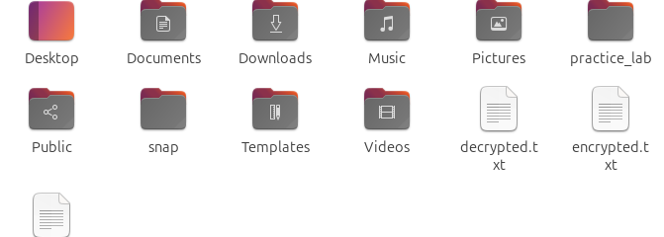

VERIFYING
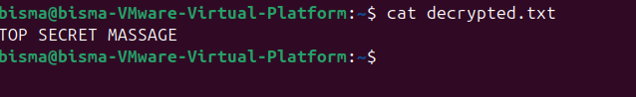

PART 02 RSA
PUBLIC KEY GENERATION
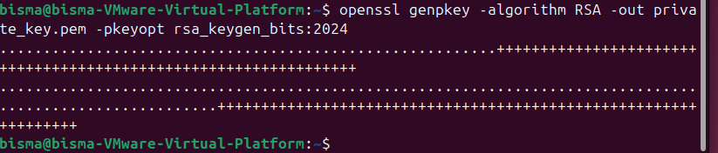
PRIVATE KEY GEN
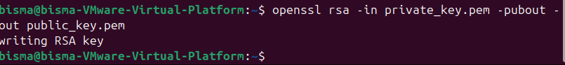
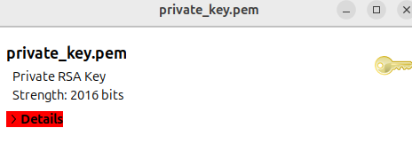
ENCRYPTION
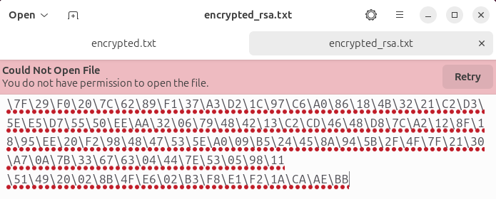
DECRYPTION
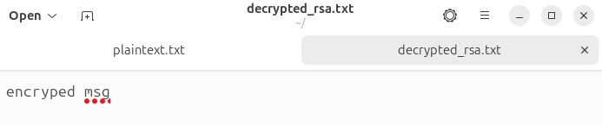
TASK 03:
PART 1:
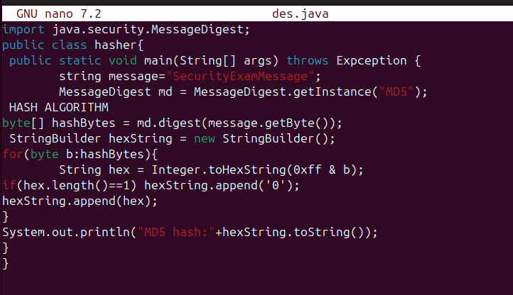
MODIFICATION
nano Hasher.java
import java.security.MessageDigest;

public class Hasher {
public static void main(String[] args) throws Exception {
String message = "SecretExamMessage";
MessageDigest md = MessageDigest.getInstance("SHA-256");
byte[] hashBytes = md.digest(message.getBytes());

StringBuilder hexString = new StringBuilder();
for (byte b : hashBytes) {
String hex = Integer.toHexString(0xff & b);
if (hex.length() == 1) hexString.append('0');
hexString.append(hex);
}

System.out.println("SHA-256 Hash: " + hexString.toString());
}
}
javac Hasher.java
java Hasher

COMPILATION
